Database Design Justification
Introduction
The database is designed to support the operation of the Malware Detection and Remediation System by storing structured knowledge about known malware, static detection rules, remediation guidance, file scan events, and detection outputs.
The database will be implemented using a relational model due to the structured and linked nature of the data, and to support SQL-based querying from the backend API. The relational approach also provides referential integrity, facilitating consistent linkage between knowledge base entries and detection results.

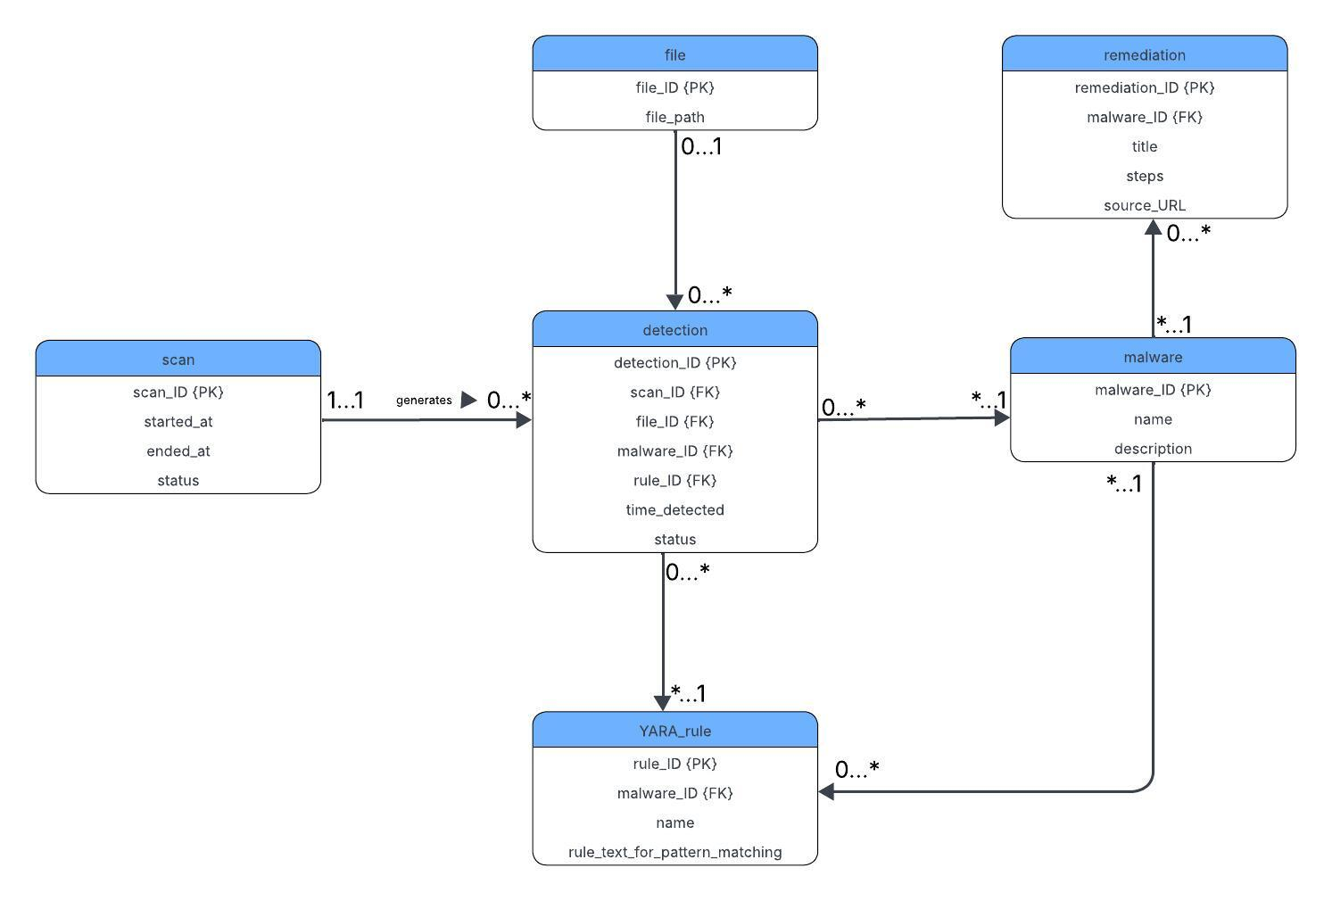

Entity Descriptions and Design Rationale
Scan
- This entity records details of the file system scanning sessions initiated by the user via the front-end. Each record captures the start time, end time, and final status of the scan. This enables the system to produce historical logs of past executions and link multiple detections to a single session.

File
- This entity stores file paths for items scanned by the detection engine. It is limited to files associated with positive detections, meaning the schema does not persist clean files to reduce database load and complexity. This reflects a design choice prioritising malware-related data over comprehensive host file indexing.
Detection
- In this entity, each row represents a positive malware detection event. It links a specific file to a specific scan, and where applicable to a YARA rule used for classification and to an identified malware entry. Each detection includes a timestamp and a status field to support later remediation or annotation workflows.
Malware
- This entity serves as a knowledge base representing a known malware family or classification label. It contains descriptive fields to support user understanding via the dashboard.
YARA Rule
- This entity stores static detection rules that are used when a scan is initiated. The rules are written using YARA’s signature syntax and consumed directly by the Python detection engine. Maintaining rules in the database supports modular updating of signatures without modifying source code.
Remediation
- This entity contains structured remediation steps and advice after a file has been scanned and identified. It supports the system objective of not only detecting malware but presenting actionable remediation guidance to the user. The schema permits multiple remediation guides per malware entry, enabling future extensibility such as OS-specific or manual vs automated remediation methods.

Relationship Design and Multiplicity Justification
The relationships between the entities were defined based on how data flows through the detection pipeline and how malware-related knowledge is structured.
- Scan → Detection (1…*) – a single scan session may generate zero or more detection records, while each detection belongs to exactly one scan. This reflects the sequential nature of file inspection during a scan.
- File → Detection (1…*) – a file may generate multiple detections across different scans, but each detection refers to a single file.
- Malware → Detection (1…*) – a malware entry may be detected multiple times across scans and files, while each detection is linked to at most one malware.
- Malware → YARA_rule (1…*) – a malware entry can be associated with multiple static rules. This reflects real-world malware analysis where multiple YARA rules may target different signatures, unpacked layers, or variants of the same malware family.
- Malware → Remediation (1…*) – a malware entry may have several remediation guides. This supports system extensibility without requiring changes to the schema.
- Detection → YARA_rule (*…1) – multiple detection entries may reference a single YARA rule if triggered via static analysis.

Conclusion
The database schema successfully models the core data needs of the system, balancing functional coverage with implementation feasibility. It shows the operational workflow of scanning and detection while enabling remediation guidance through a structured knowledge centre.

